Negotiation Preparation

Workbook

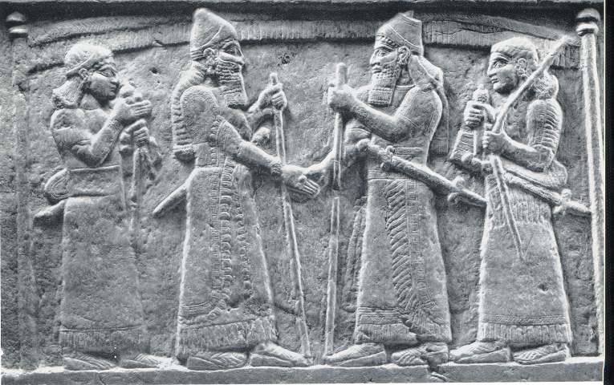

**Goals for the Negotiation**

What is the ideal outcome of your negotiation? What is the essence of what you are hoping to achieve?

Ideally, what would your relationship with the other party be like at the end of the negotiation?

How do you want to behave during the negotiation? What values do you want to express? What do you want to do differently than you have in the past?

**Substance and Relationship in the Negotiation**

On the graph below, put a dot where this negotiation falls in terms of relationship and substance.

High

Low

Importance of Substance

High

Importance of Relationship

How does this information inform your strategy for the negotiation?

**Diagnosing Their World**

What do you know about the other party’s hopes and fears?

What are his/her core concerns?

Who are the other people connected with the other party, and how might this impact them?

Based on what you know, what is the other party’s opinion of you? Your relative power, status, and influence?

**Trading Currencies**

What trading currencies do you have to offer in the negotiation? What specific tactics could you use to offer these currencies as part of your negotiation?

|  |  |
| --- | --- |
| Currency | What you Offer |
| Inspiration |  |
| Task |  |
| Position |  |
| Relationship |  |
| Personal |  |

**Disclosure**

What information about your position do you absolutely want to disclose?

What information would you share freely if the conversation requires it?

What information should you be especially strategic and tactful about sharing ?

What information are you absolutely unwilling to share?

**Objective Criteria**

If you had the time and resources, what would you want to find out about relevant professional standards, legal precedents, scientific findings, market price, expert opinions, etc?

|  |
| --- |
|  |
|  |
|  |
|  |
|  |
|  |
|  |
|  |

**BATNA – Best Alternative to a Negotiated Agreement**

What’s next for you if you can’t come to an agreement?

What can you do to improve upon this plan, so that you are in a better position if you cannot come to an agreement?

What do you know about the other party’s BATNA?

How would you compare your BATNA to theirs? Is theirs better than yours, or vice versa? How much is at stake for both of you in being able to reach an agreement?